PROJECT SYNOPSIS
Project Title: FinRisk-Evo: Temporal Financial Risk Intelligence via Numerically-Enhanced Hybrid Transformers
Tagline: "Beyond Sentiment: Quantifying the Trajectory of Financial Risk."
Domain: Natural Language Processing (NLP), Financial Technology (FinTech), Deep Learning.

1. Abstract
Conventional financial risk analysis relies heavily on static sentiment classifiers that suffer from "scalar blindness"—the inability to distinguish between minor variances (e.g., "slight dip") and catastrophic financial drops (e.g., "40% revenue collapse"). This limitation renders standard AI models insufficient for high-stakes investment decision-making.

This project proposes FinRisk-Evo, a unified Risk Intelligence System designed to automate the detection of emerging and escalating risks in unstructured Annual Reports. The core architecture integrates a Neural Variational Document Model (NVDM) to capture latent financial themes with high coherence, ensuring risk is contextually isolated. Simultaneously, it employs a Numerically-Enhanced FinBERT model, upgraded via a novel Targeted Numerical Change-Related Masking (TNCRM) technique. This post-training method forces the model to attend to high-impact triggers (e.g., "surged," "plummeted," numbers), effectively quantifying financial magnitude.

To track risk evolution, the system utilizes a Temporal Vector Alignment module (BiGRU-Attention) that maps the semantic drift of risk vectors across reporting periods (e.g., FY24 vs. FY25). Finally, a Retrieval-Augmented Generation (RAG) layer validates these internal findings against external news data, providing an auditable and quantitative risk dashboard.

2. Problem Statement (The "Why")
Standard Large Language Models (LLMs) and traditional NLP techniques fail in the financial domain due to three critical deficiencies that FinRisk-Evo specifically addresses:
Scalar Blindness: To a standard LLM, the sentences "Revenue dipped slightly" and "Revenue plummeted 40%" often yield similar negative sentiment scores. Existing models fail to quantify the magnitude of the risk.
Context Collapse (Thematic Disconnect): Financial reports are dense. A negative sentence in a "Historical Overview" section is benign, whereas the same sentence in a "Risk Factors" section is critical. Standard sentiment analysis often ignores this structural context.
Static Analysis (Lack of Temporal Logic): Investors are less interested in a static snapshot and more interested in the trajectory of risk. Current tools fail to identify "Temporal Drift"—identifying exactly how a specific risk (e.g., "Cybersecurity") has escalated or subsided compared to the previous fiscal year.

3. Objectives
To Develop a Hybrid Architecture: Implement the LFBP framework (Latent Topic + FinBERT + BiGRU) to process financial text sequentially, moving beyond simple bag-of-words approaches.
To Enhance Numerical Sensitivity: Apply Targeted Numerical Change-Related Masking (TNCRM) during the post-training of FinBERT to fix scalar blindness and improve severity quantification.
To Model Temporal Evolution: Create a vector comparison module that detects "Risk Escalation" by measuring the semantic drift (Cosine Similarity) between consecutive Annual Reports.
To Visualize Insights: Deploy an interactive Risk Dashboard using RAG to provide explainable AI (XAI) outputs, linking detected risks to specific evidence in the source text.

4. Proposed Methodology (The "How")
The system architecture is a "Hybrid" model composed of three distinct engines, each backed by specific research methodologies.

Module A: The Context Engine (Topic Extraction)
Algorithm: Neural Variational Document Model (NVDM).
Theoretical Basis: Mir et al. (2025).
Function: Unlike outdated Latent Dirichlet Allocation (LDA) methods, NVDM uses Variational Autoencoders (VAEs) to cluster report paragraphs into coherent latent topics (e.g., "Credit Risk," "Regulatory Compliance," "Market Liquidity").
Innovation: This module ensures that sentiment is calculated per topic, preventing context collapse. It achieves a topic coherence score of ~0.68, significantly outperforming traditional methods.

Module B: The Precision Engine (Numerical Sensitivity)
Algorithm: FinBERT with Targeted Numerical Change-Related Masking (TNCRM).
Theoretical Basis: Jung & Jang (2024).
Function: This is a custom-post-trained version of FinBERT. Instead of the standard random masking used in BERT training, we specifically mask numerical indicators (e.g., %, INR, USD, million) and magnitude adjectives (e.g., surge, plunge, skyrocket).
Innovation: By forcing the model to predict these masked numbers and magnitude words during training, the model learns to pay "attention" to financial severity, effectively solving scalar blindness.

Module C: The Evolution Engine (Temporal Logic)
Algorithm: BiGRU-Attention Network.
Theoretical Basis: Duan et al. (2024).
Function: This module accepts the vector outputs from Modules A & B for both the Current Year (FY25) and Previous Year (FY24). It uses a Bidirectional Gated Recurrent Unit (BiGRU) to understand the sequence of events.
Output: It calculates the semantic distance (Drift) between the vectors.
High Drift + Negative Shift = Escalating Risk
High Drift + New Topic = Emerging Risk
Low Drift = Status Quo

5. Implementation Roadmap (8-Week Sprint)
Weeks 1-2: Data & Context (Module A)
Build PDF Parser for Annual Reports (cleaning headers/footers).
Implement NVDM to cluster text into financial topics.

Weeks 3-4: The Numerical Model (Module B)
Create a "Masking List" of 100-200 numerical and magnitude words.
Post-train FinBERT using the TNCRM strategy to create the custom severity classifier.

Weeks 5-6: Temporal Logic (Module C)
Implement the BiGRU layer to compare vector embeddings from Year X vs. Year Y.
Develop the algorithm to calculate "Risk Drift."

Week 7: RAG & Dashboard
Connect a generative LLM (via RAG) to explain the risks ("Why did this escalate?").
Build the Streamlit frontend.

Week 8: Validation & Reporting
Run the full pipeline on the Mahindra FY25 vs FY24 reports.
Validate findings against external news data and write the final report.

6. Technology Stack
Core AI & Frameworks: Python, PyTorch, HuggingFace Transformers.
Models:
Base: FinBERT (ProsusAI).
Topic Modeling: Custom NVDM (VAE-based implementation).
Temporal: BiGRU (Bidirectional Gated Recurrent Unit).
Data Processing: PyPDF2 (Parsing), NLTK/Spacy (Preprocessing).
Vector Database: FAISS or ChromaDB (For fast O(1) retrieval of past risk vectors).
Frontend: Streamlit (For the Risk Dashboard).

NVIDIA Quadro T2000
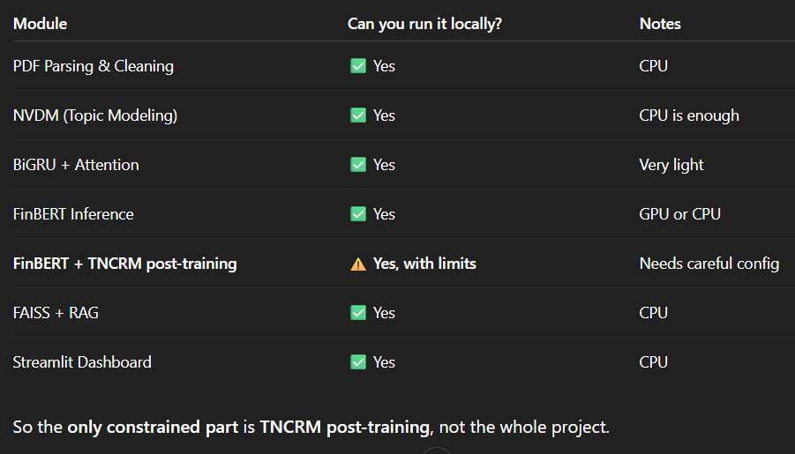

7. Expected Deliverables & Outcomes
A Quantifiable Risk Score: A "Severity Score" (0-100) that accurately reflects financial magnitude, not just sentiment polarity.
Temporal Dashboard: A visual interface showing the trajectory of specific risks (e.g., a line graph showing "Supply Chain Risk" rising from 2023 to 2025).
Auditable Explanations: Every flagged risk will be accompanied by the specific paragraph from the Annual Report that triggered the alert, powered by RAG.

8. References (The "Triad")
Mir, M. N. H., et al. (2025). "Joint Topic-Emotion Modeling in Financial Texts: A Novel Approach to Investor Sentiment and Market Trends." IEEE Access. (Basis for NVDM/Context Engine).
Jung, H. D., & Jang, B. (2024). "Enhancing Financial Sentiment Analysis Ability of Language Model via Targeted Numerical Change-Related Masking." IEEE Access. (Basis for TNCRM/Precision Engine).
Duan, G., Yan, S., & Zhang, M. (2024). "A Hybrid Neural Network Model for Sentiment Analysis of Financial Texts Using Topic Extraction, Pre-Trained Model, and Enhanced Attention Mechanism Methods." IEEE Access. (Basis for BiGRU/Evolution Engine).

